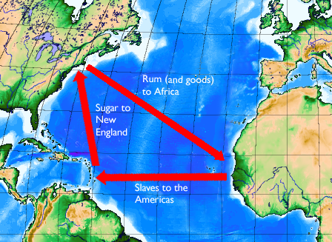

Triangle Trade
5th Grade Social Studies
Duration: 30-40 minutes
Chrissy Gutenberger

Purpose: This lesson is being taught in order to explain to the students the process of the Triangle Trade. It is the introduction to this months Unit on Slavery.

Objectives: 1. The students should be able to state the three continents involved in
the Triangle Trade.
2. Students should be able to identify which continents trade with one
another.
3. Students should be able to identify the goods/slaves that are traded
between continents.

New York State Learning Standards:
Standard 3: Geography
Use a variety of intellectual skills to demonstrate their understanding of the geography of the interdependent world in which we live—local, national, and global—including the distribution of people, places, and environments over the Earth’s surface.
Standard 4: Economics
Use a variety of intellectual skills to demonstrate their understanding of how the United States and other societies develop economic systems and associated institutions to allocate scarce resources, how major decision-making units function in the U.S. and other national economies, and how an economy solves the scarcity problem through market and nonmarket mechanisms.
• Understands how the values and institutions of European economic life took root in the colonies and how slavery reshaped European and African life in the Americas
Pre-Assessment: KWL chart
- Students will write down in a chart what they already know about slavery
- Students will write what they want to no about the triangle trade
- At the end students will fill in for homework what they have learned

Lesson Presentation:
- Set Induction: KWL?
  - Now that you have a better understanding of slavery from out previous lesson, I will begin teaching how the slaves were brought to our country. We took the goods that we naturally produced from North America and traded them with other countries in order to receive slaves.
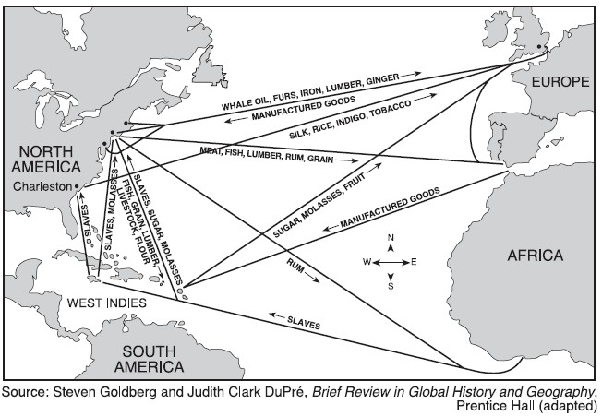
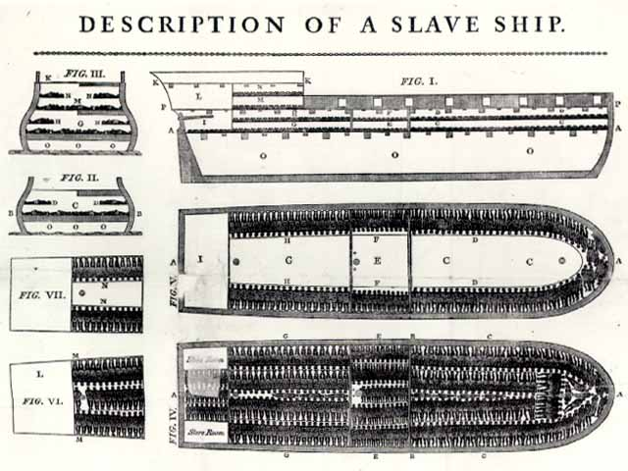
- Procedure:
  - Today we will be beginning our Unit on Slavery. We will begin with the Triangle Trade.
    - Does anyone know what the Triangle Trade is?
  - The Triangle Trade is a route or a pathway that is used to receive slaves and trade goods with other continents.
    - This trade is made up of three points, which include Europe, Africa, and North America.
    - These three points make up a triangle, giving the triangle trade its name (three continents will be on blackboard and teacher will draw the paths of the trade on the blackboard between continents).
  - The triangle trade began in Europe then went to Africa and then to North America.
    - Europe to Africa: exchanged goods
      - Copper
      - Manufactured Cotton
      - Silks from Asia
      - Guns and Ammunition
      - Glassware
      - Manila
      - Pots
    - Africa to North America
      - Enslaved men
      - Enslaved women
      - Enslaved Children
      - Indigo
    - North America to Europe
      - Rum
      - Sugar
      - Rice
      - Coffee
      - Tobacco
      - Cotton
  - What did North America want from this trade?
    - North America wanted Slaves
  - Now that you have a general idea on what the Triangle Trade is we will begin a short activity.
    - As you can see you are sitting in three groups of desks
    - Each desk is a continent: Europe, Africa, North America
    - There are cards on the desks that indicate the goods or slaves you will be exchanging with other countries.
    - One by one deliver your goods to the country you are supposed to be trading with.
      - Who is my Europe group trading with? Africa
      - Who is my Africa group trading with? North America
      - Who is my North America group trading with? Europe
v. Once you have exchanged your goods, can one person from each continent come up to the board and write under your continent what you now have.
C. Closure:
a. As you can see, these three continents benefited from these trades and
helped with the development of each continents economy.

Materials and Resources:
- Maps of Continents
- Blackboard/Dry erase board
- Note cards with goods/slaves on them
- Pens and Pencils
- Coloring Materials

Follow-Up Activity:
- For homework the students will be drawing their own map of the triangular trade.
  - Must Include:
    - 3 continents
    - Arrows depicting the trade routes
    - Colored with a key
    - Goods/slaves are being traded

Evaluation/Assessment:
  - Students will complete the section on the KWL chart on what they learned. This will give a good understanding on if they learned the material.

Integration:
- Multiple Intelligences:
  - The students will be learning about the triangular trade in a visual, kinesthetic, and auditory way. This way all learning styles are covered and all the students will grasp the concept in one way or another.
- Integration:
  - This lesson integrates social studies with Art and English.
    - English: For the evaluation, the students will be filling in a KWL chart.
    - Art: For homework, students will be making their own Triangle Trade with coloring utensils.

What I Know: | What I Want to Know: | What I have Learned:

Activity on the Triangle Trade

Desk Arrangements Europe

3

North America

1

2

Africa
Exchange of Goods and Slaves
- Europe to Africa
  - Copper
  - Manufactured Cotton 3. North America to Europe
  - Silks from Asia a. Rum
  - Guns and Ammunition b. Sugar
  - Glassware c. Rice
  - Manila d. Coffee
  - Pots e. Tobacco
- Africa to North America f. Cotton
  - Enslaved Men
  - Enslaved Women
  - Enslaved Children
  - Indigo

Explanation of Activity:

1. Each group of desks is a continent
a. They will all have a map of their continent in the center of the desks.

2. Each group will have a set of cards.
a. The cards will have goods and/or slaves on them and it is the students’
jobs to trade the goods with the correct continent.

3. Groups will then trade with each other, creating the Triangle Trade.

Example Answer Key:

What I Know: | What I Want to Know: | What I have Learned:
Answers May Vary:  Slavery existed in the US  Slaves Came from Africa  Slaves were bought and sold  Slaves worked on plantations  People had to pay for slaves | Middle Passage  Slavery  Cause and Effect of Slavery | Vocabulary: slave trade  Middle Passage, cargo, longitude and latitude.  _____________________  Slavery was needed in order to produce cash crops that were given back to mother countries.  Slavery later became one of the causes of the civil war in the US

